Water for the Reservation - AC 2020 Mission Project
By Billie K. Fidlin, Director of Outreach & Justice
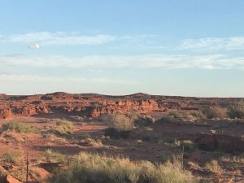
Imagine. For just a moment, walk with me, through more than 27,000* square miles in Arizona, New Mexico and Utah. 27,000 square miles of many homes without running water or other infrastructure that many of us simply live with daily as part of our “normal”. A place where the temperatures vary from 15F to 83F. Imagine heating through only the use of propane or firewood in so many homes. A place where seasonal torrential rains render many unpaved roads impassible and flash floods are common. Imagine meeting your economic needs with a median household income of $20,005.00.

Imagine a people with a spirit of survival and triumph. A people who value not only their elders, but as a matriarchal society have a strong sense of family allegiance and obligation. A people who place value on 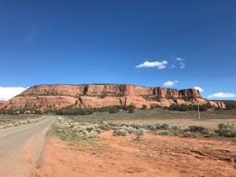tradition and realize the stress brought about by reservation to urban migration. A people who’s courage is exhibited in the Navajo Code Talkers from World War II. Navajo artists whose works are in many of our homes – from their woven rugs and blankets to jewelry of silver and turquoise. As the largest tribe their population as of the 2016 count equaled 356,890 tribe members – and roughly 170,000 Navajos still speak Navajo. Such heritage!
A rich history. A painful history such as in 1864, when thousands of Navajos were forced to surrender to American soldiers, enduring “The Long Walk” to Ft. Sumner New Mexico where they lived and died in horrible conditions from beginning to end. A history that includes the creation of the Four Corners Ministry, “Where the Holy Spirit Touches Navajo Hearts.”** A history of trials and great achievement.

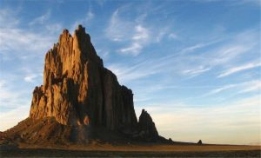While this background is interesting, perhaps this very day is of more immediate interest. Why should the people of the Desert Southwest Conference concern themselves with the Navajo Nation? Among the many reasons: we are a people of faith who care for the vulnerable; many of our churches send work teams to sites on the reservation for hands-on mission trips; and we engage in ministry on the reservation, from Bible studies near Page to the United Methodist Church presence in concert with the Four Corners Ministry.

But there is one painful event that is drawing our attention to mission. COVID-19. The virus is devastating the Navajo. The greatest deterrent, simply washing our hands frequently, for many is impossible. It is hard to wash hands without running water. Hospitals are few and not easily traveled to. We cannot do much about the hospital access. We can help with water. As of April 29, 2020, 1,977 positive cases have been identified for COVID-19, with 62 deaths. These numbers rise daily. With population dispersal throughout the region and the lack of accessibility to health care and water, as with many parts of the country these statistics represent only what is known for certain and may not reflect accurately how the virus has impacted the people. Additionally, as Rev. Tweedy Sombrero, former chair of the Conference Committee on Native American Ministries shared, “Part of the reason COVID is spreading so fast, culturally families live in clusters and a handshake is very important. To greet one another with a handshake is very important and then all of a sudden one cannot do this or see each other is devastating to tribal members.”
This year’s Annual Conference Mission Project is to receive donations that will be put toward providing water where it is needed on the reservation. While we understand that many of us have experienced furloughs or job lay-offs, we also understand the mission heart of the Desert Southwest Conference. Your donation can be made electronically or by post mail. Please remember to indicate that this is for Mission Project 2020: Water!
Online Giving
NOTE: In “Purpose of Payment” please note AC Mission Project 2020. In “Other Details” please list your church name
Mail in giving: Desert Southwest Conference PO Box 32830 Phoenix, AZ 85064
NOTE: On your check please note AC Mission Project 2020 & please list your church name

We know these are difficult times for all of us. Please help as you can, but also know the most important help of all is prayer.

Now something to celebrate!
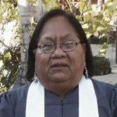Rev. Tweedy Sombrero will soon leave our Conference to serve the Four Corners Ministry in New Mexico. We share as a Conference in this ministry and celebrate her appointment there. Look for more about this important ministry in a future Mission Project 2020: Water! article.

Thank you friends. May you be safe, healthy, and filled with God’s love.
Note: Our Conference is honored to be working with the Navajo COVID-19 Command Center, Window Rock, in the distribution of water humanitarian aide regarding all Conference donations for the Navajo Nation. Questions? Please contact Billie Fidlin at bfidlin@dscumc.org

