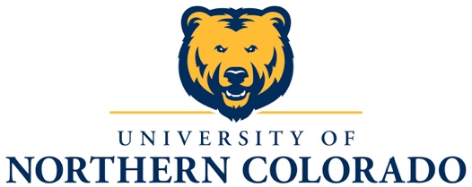

College of Performing and Visual Arts
School of Music

University of Northern Colorado Chamber Choir
Southwest U.S. Performance Tour
May 9-17, 2016

Performances:
Glenwood Springs Middle School, Glenwood Springs, CO
Grand Junction High School, Grand Junction, CO
Chino Valley High School, Chino Valley, AZ
Chino Valley United Methodist Church, Chino Valley, AZ
Red Mountain High School, Mesa, AZ
Campo Verde High School, Gilbert, AZ
Casteel High School, Queen Creek, AZ
St. Francis Basilica Cathedral, Santa Fe, NM
El Camino Real Middle School, Santa Fe, NM
Liberty High School, Colorado Springs, CO
Castle View High School, Castle Rock, CO

Repertoire to be selected from:

Bogorodiste Devo Sergei Rachmaninoff

Ave Verum Corpus Wolfgang Amadeus Mozart

Veni Sancta Spiritus Wolfgang Amadeus Mozart

Psalm 57 John Tebay

Sing Joyfully William Byrd

Ubi Caritas Maurice Durufle
Tantum Ergo

Mass for Double Choir Frank Martin
Kyrie
Gloria
Credo
Sanctus
Agnus Dei

Firelight Braeden Ayres

Lux Aeterna Ivo Antognini

Le Pont Mirabeau Lionel Daunais

Entreat Me Not to Leave You Dan Forrest

My God is a Rock Ken Berg

It Takes a Village Joan Szymko

Worthy to Be Praised Byron Smith

UNC Chamber Choir Personnel
Dr. Jill Burgett, Conductor
Tim Klingler, Will Ecker, Braeden Ayres, Graduate Assistants
Katie Hughes, Accompanist

Sopranos
Tiffany Bergland, Colorado Springs, CO
Lindsay Dean, Colorado Springs, CO
Katie Hughes, Boulder, CO
Louisa Jones, Colorado Springs, CO
Sarah Kochevar, Broomfield, CO
Kara Kupecki, Round Rock, TX
Nicole Louis, Colorado Springs, CO

Altos
Raleigh Fairchild, Arvada, CO
Claire Jensen, Ft. Collins, CO
Ashley Patin, Muskego, WI
Elizabeth Scarselli, Loveland, CO
Hannah York, Aurora, CO

Tenors
Anthony Azari, Greeley, CO
Preston Adams, Aurora, CO
Braeden Ayres, Grapevine, TX
German Duarte, Grand Junction, CO
Paul Heineke, Colorado Springs, CO
Tim Klingler, Mesa, AZ
Shane Mosser, Wheat Ridge, CO

Basses
Allen Adair, Grand Junction, CO
Jake Betz, Mesa, AZ
William Ecker, Ft. Collins, CO
Zechariah Oswald, Loveland, CO
Ryan Plakorus, Arvada, CO
Alex Zhang, Chengdu, China

University of Northern Colorado School of Music
College of Performing and Visual Arts
Frasier Hall, Room 108, Campus Box 28
Greeley, CO 80639 970-351-2993
arts.unco.edu music@unco.edu

